# Defect in DacFx extracting a DacPac with nullable persisted computed columns

## Versions

* Visual Studio 2017 Professional – Version 15.8.5
* .NET Framework Version 4.7.03056
* SQL Server Data Tools Version 15.1.61808.07020

## Scenario #1 – Using a extracted dacpac

I have a sql server database project with one table [dbo].[ATable], an ID column, a date column and a persisted computed column. As below: -

CREATE TABLE [dbo].[ATable]

(

[ID] INT NOT NULL PRIMARY KEY,

[ADate] DATE NOT NULL,

[DayOfYear] AS (dbo.[CalcDayOfYear]([ADate])) PERSISTED

)

I have a scalar function which is schemabound that calculates the day of year based on a date passed in:

CREATE FUNCTION dbo.CalcDayOfYear

(

@CalcDate DATE

)

RETURNS SMALLINT

WITH SCHEMABINDING

AS

BEGIN

RETURN ((CONVERT(SMALLINT, DATEPART(DAYOFYEAR, @CalcDate ))))

END

I can publish this without any issues using the publish tools in visual studio:

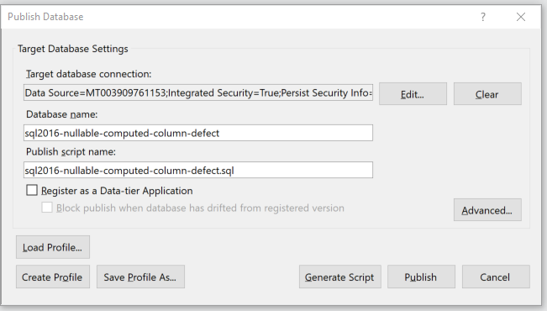

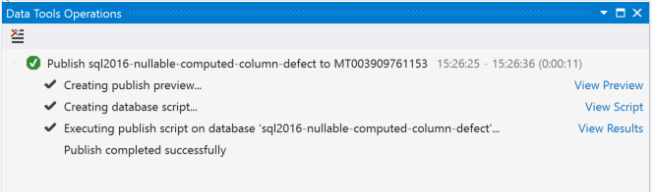

When I extract the dacpac off the database using the below script:

"C:\Program Files (x86)\Microsoft Visual Studio\2017\Professional\Common7\IDE\Extensions\Microsoft\SQLDB\DAC\150\sqlpackage.exe" /Action:Extract /OverwriteFiles:True /TargetFile:".\ExtractedDacPac\sql2016-nullable-computed-column-defect.dacpac" /SourceDatabaseName:sql2016-nullable-computed-column-defect /SourceServerName:.

And compare it to the project using the compare schema tool in visual studio:

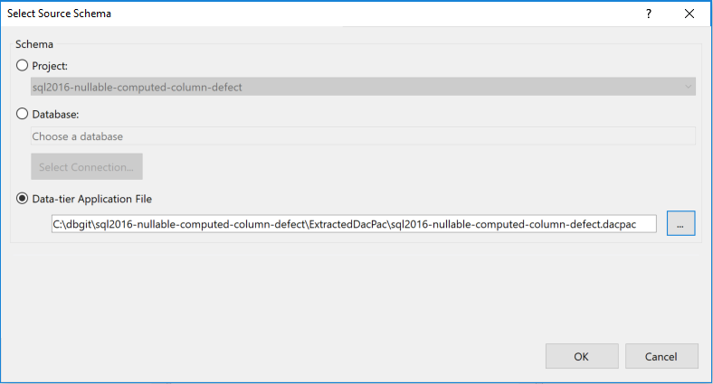



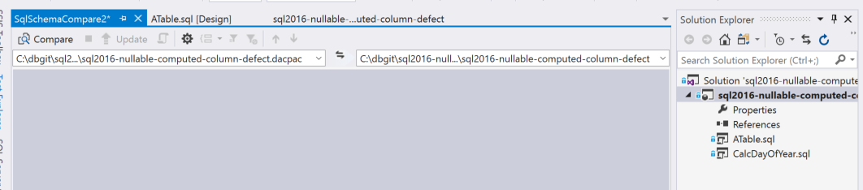



When I select “Compare” the Results show that there is a difference and its due to the IsPersistedNullable property:

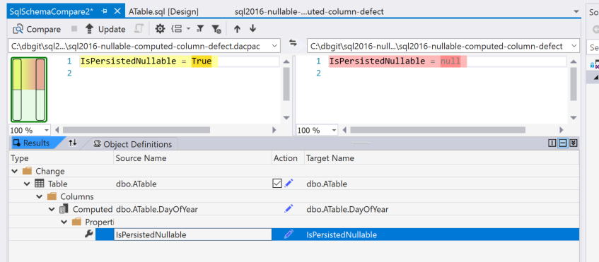

When I try and add the persisted column as nullable, I am presented with a syntax error as below:

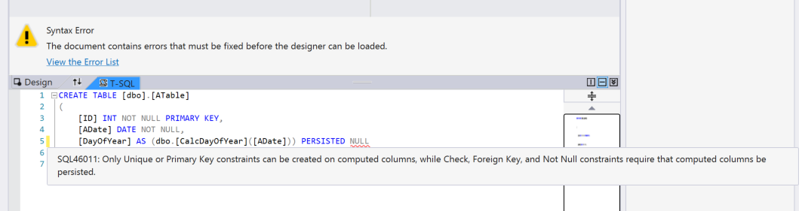

## Conclusion

In my opinion the publish or building of the db project should have identified that the syntax:

[DayOfYear] AS (dbo.[CalcDayOfYear]([ADate])) PERSISTED

Is invalid or should have automatically added the computed column as not nullable as it’s a persisted computed column, and the compare should ignore it as a difference.

## Github.com Repo

I have added the defect to github.com for your convenience so that you can run through the scenarios:

<https://github.com/fenngineering/sql2016-nullable-computed-column-defect>

Thanks

Andrew